**Creation of AMIs:**

* If we want to take the backup of whole server. We can use AMIs.
* Right click on the EC2 instance 🡪 create an image.

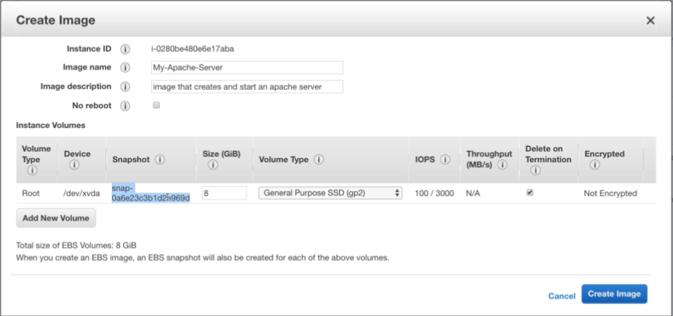

* Give a name and description to the image and then create it.
* If we leave no reboot as uncheck then it will reboot the instance, but the data will be consistent
* If we check the no reboot, it creates image on fly which makes the data inconsistent
* After this, we can check the image details at AMIs option under images section
* We can refresh and check the snapshots after this. The snapshots will be created automatically

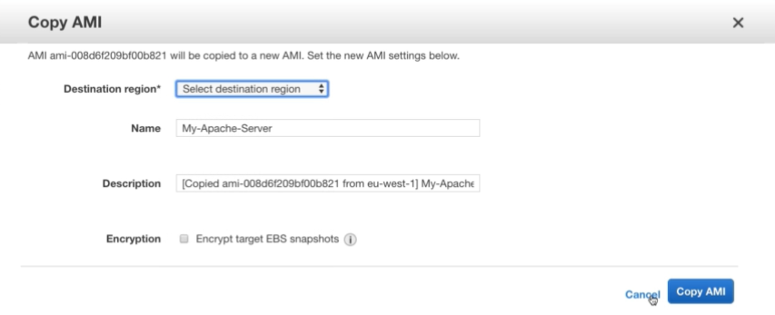

* We can copy the image to any other region by right clicking on the image and select copy image option.

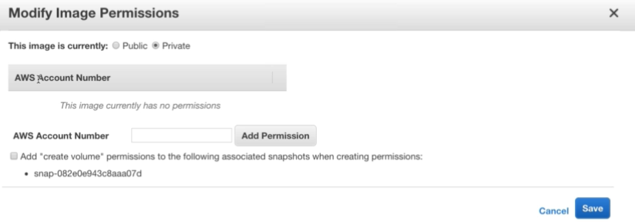

* We can also modify the permission so that other people or other AWS account can see or access it.
* We can right click and launch it.

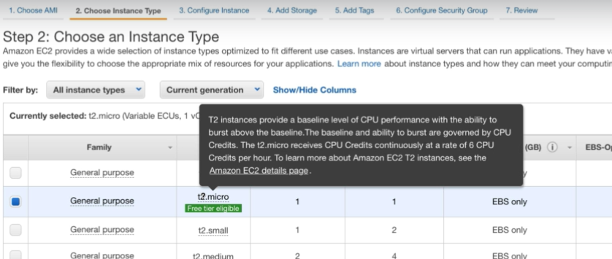

* We need to select the instance type

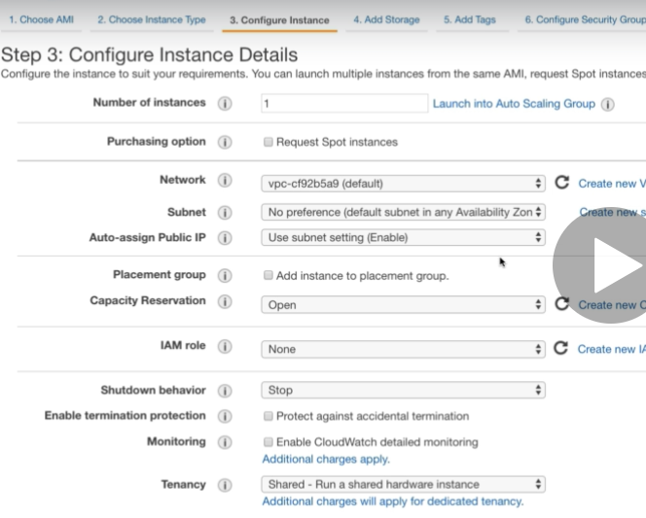

* And the configuration.

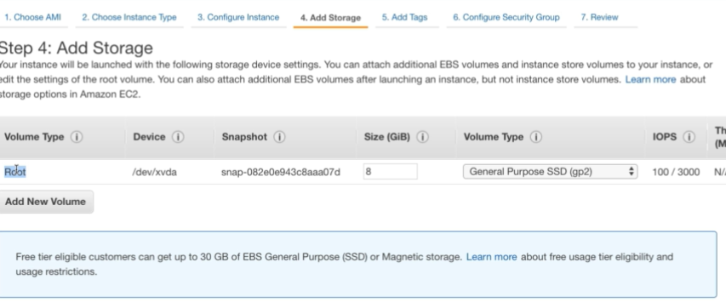

* Also, storage, we can see that the root volume is coming from the snapshot.
* Then tags and security groups before we create an instance.

**We cannot launch the instance from AMI with less memory than snapshot of AMI. But we can create AMI with less memory. It is accepting but by default the snapshot is getting created as same as volume size of the instance**

**With the image, we can get the whole server backup along with installations too**